**Google Play Store: How many Entertainment apps have a content rating of Mature**

**Report and Analysis**

**Introduction**

This report will include data and information regarding the Google Play Store Entertainment apps, specifically the ones rated as mature. The dataset utilized for answering the user story consists of 10,841 rows and 13 columns all related to Google Play Store statistics and metrics. These ranged from the category of the app, the overall rating, installs, current version, price, and other similar factors. Meaning there are 10,841 apps and relevant information contained within the data.

The question for this task is:

The Google Play Store users would like to see how many Entertainment apps have a content rating of Mature.

**Body**

Data:

To begin the analysis, first I made sure that the necessary libraries were imported into Jupyter Notebooks. Then, I imported the data file “googleplaystoremaster.csv” to start the inspection of the data and find what was asked to be done from this data which is to find how many Entertainment apps have a mature content rating.

**Method and Results:**

To get to the point first I located and cleaned some data and then looked into the data to find how many unique values are in the column Category and how many unique values are in the column Content Rating so I could then see how many apps in the Entertainment category have the content rating of mature.

And lastly, I created a count plot of instances of each rating to compare and get an overview of the quantity belonging to each category.

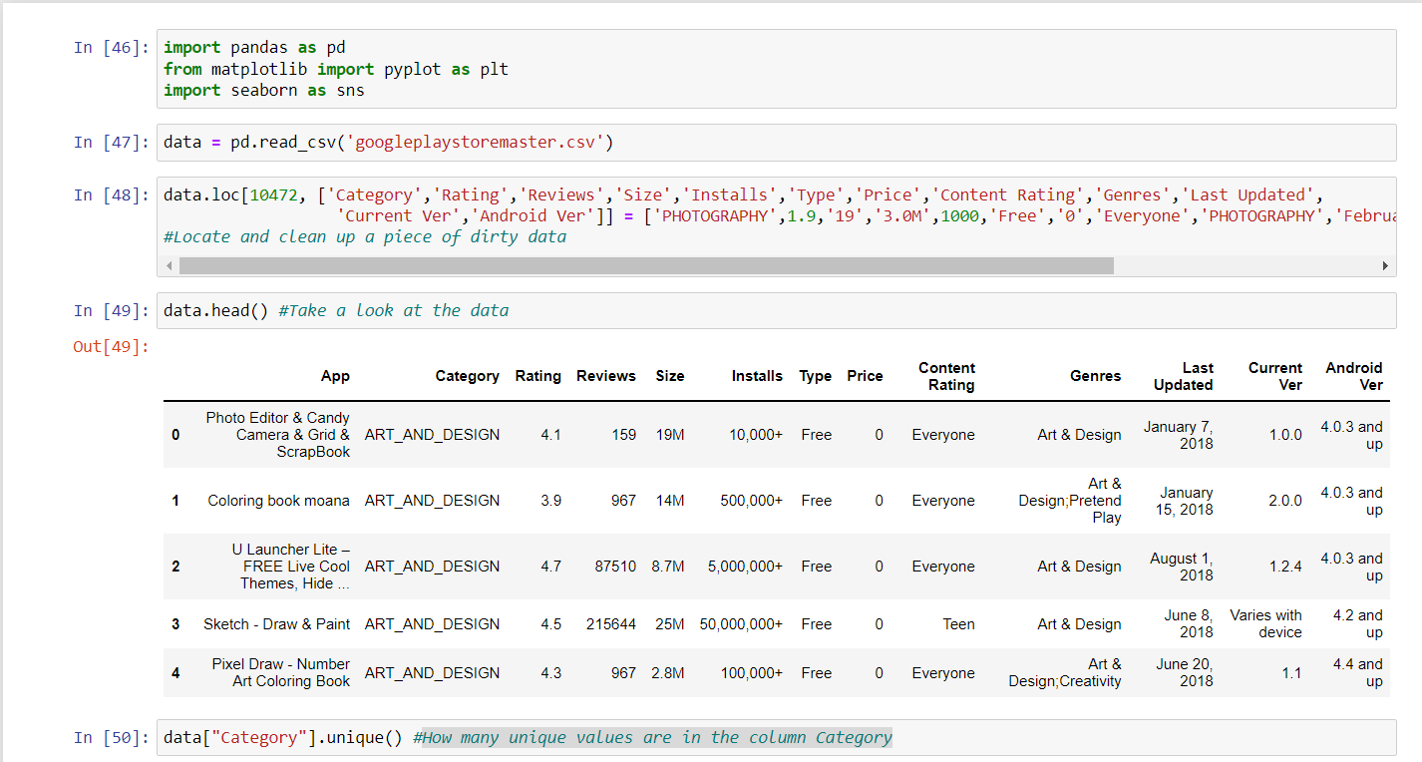

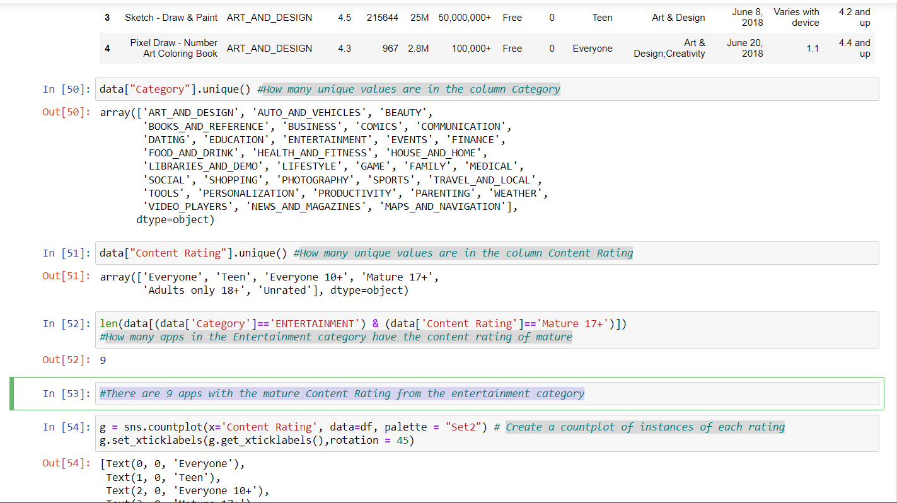

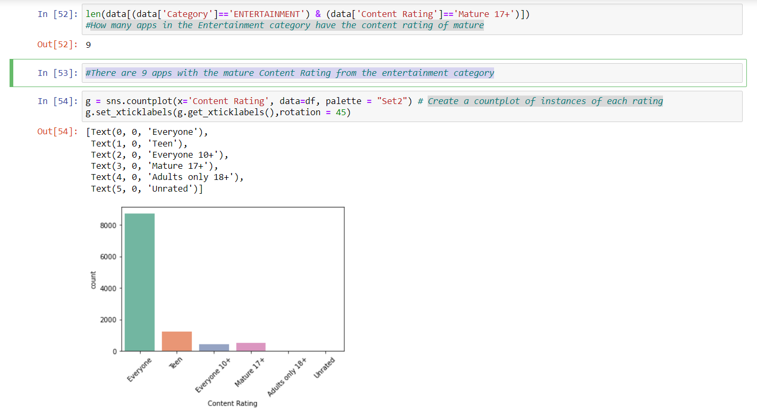

**Conclusion:**

We were able to determine that there are 9 apps with the mature Content Rating from the entertainment category.